**Name: STEBIN BABU**

**Roll No: 44**

**Batch:B**

**Date: 08-03-2022**

**ADVANCED DBMS LAB**

**Experiment No.: 3**

**Aim**

To familiarize DDL Commands- ALTER,DROP,TRUNCATE,RENAME

**QUESTION**

1.Create a table emp with attributes empno number(4)as primary key, ename char(10),hiredate,  salary, commission

insert 5 rows of data

|  |  |  |  |  |
| --- | --- | --- | --- | --- |
| 101 | Ramesh | 17-Jan  1980 | 5000 |  |
| 102 | Ajay | 05-Jul  1985 | 5000 | 500 |
| 103 | Ravi | 12-Aug  1981 | 1500 |  |
| 104 | Nikesh | 03-Mar  1983 | 3000 | 700 |
| 105 | Ravi | 05-jul  1985 | 3000 |  |

2.Modifying the structure of tables

a.Add new columns: sal number(7,2)

b.Dropping a column from a table: sal

c.Modifying existing column :ename varchar2(15)

d.Renaming the tables: emp to emp1

e.truncating the tables:emp1

f.Destroying tables:emp

3.Create a table stud with sname varchar2(20) primary key , rollno number(10) not null,dob  date not null

4.Create a table student as regno number (6), mark number (3) check constraint (mark >=0 and  mark  <=100));

In table student add check constraint(length(regno<=4))

5.Create a table cust with(custid number(6) constraint unique, name char(10) 6. Refer the table “stud” in table “ student”

**PROCEDURE AND OUTPUT SCREENSHOT**

1. **EMP table (Create and Insert)**

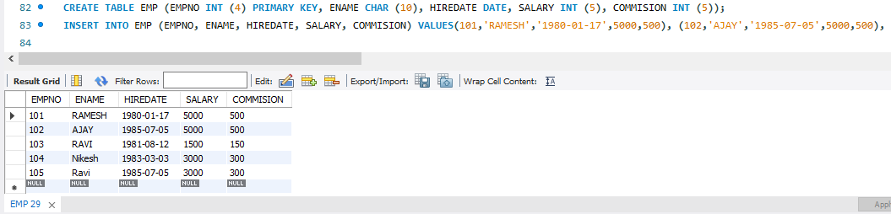

**2.Modifying the structure of tables**

**a.Add new columns: sal number(7,2)**

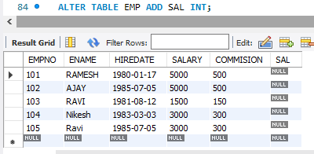

**b.Dropping a column from a table: sal**

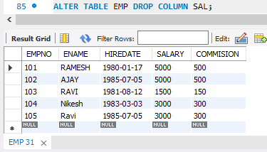

**c.Modifying existing column :ename varchar2(15)**

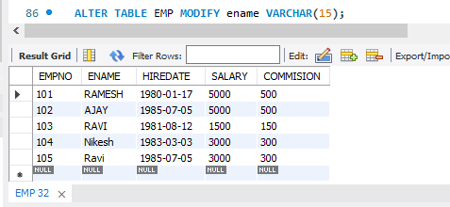

**d.Renaming the tables: emp to emp1**

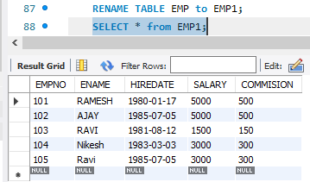

**e.truncating the tables:emp1**

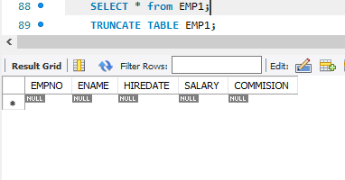

**f.Destroying tables:emp**

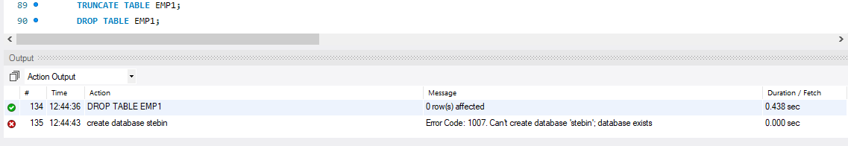

**3 .STUD table**

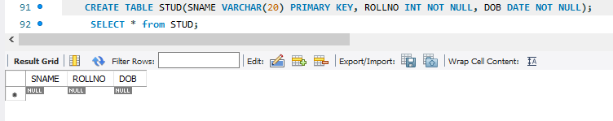

**4.STUDENT table**

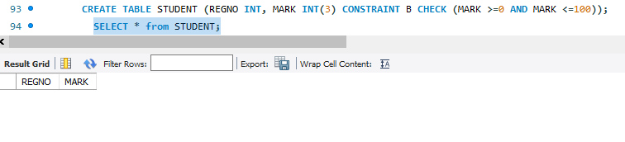

**5. CUST Table**

